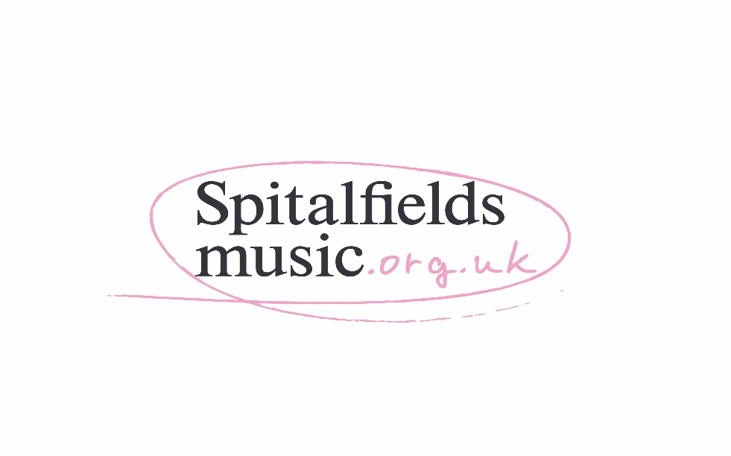

Thank you for your interest in finding out more about being a volunteer steward with Spitalfields Music – here is some initial information.

Why are stewards needed?
We need extra help to run our events safely and smoothly. Without the support of our committed and enthusiastic volunteer stewards, we would not be able to put on our festivals. Stewards are often the first point of contact at a concert for an audience member and are key to ensuring that the audience’s experience of the Festival is the best it can possibly be.

What do stewards do?
In addition to specific roles allocated at each event such as ticket checking and programme selling, your role is to:
- Welcome the audience to the Festival
- Help to direct audience members safely around the building
- Respond to audience members’ queries
- Keep your eyes open for any hazards and report any concerns to the Event Manager
- Be alert to anyone needing first aid and raise the alarm if you discover a fire or emergency situation
- Hear some fantastic music!

Is there an age limit?
You need to be 18 or over to steward with us at the moment. There is no upper age limit as long as you are reasonably fit. Please contact Lila if you have any questions about this before registering.

Will there be any training?
- Before the Festival
  - We’ll ask you to attend an evening group training session and a briefing which will cover everything you need to know. These are usually in one of the Festival venues and last about 60-90 minutes.
- During the Festival
  - Everything you need to know about a specific event will be covered at the briefing at the beginning of your shift and we will ensure you are familiar with the venue. Staff are always on hand to answer questions and you will receive a handbook.

What’s the time commitment?
We ask you to commit to a minimum of three events (can be of any type/mix) to give you a good flavour of the Festival. Some people have more time than others – our current steward team includes people who work and those who don’t. We really appreciate you giving us your time and are happy to advise on what might suit you. The Winter Festival 2018 runs from 1st – 9th December.

What’s next?
Once we have received your registration form, we’ll contact you to arrange an introductory meeting where you can find out more about us and the role and you’ll meet other interested people.
The other important date for your diary is the pre-festival briefing. We ask all stewards to attend this, especially if this is your first Festival.

Am I entitled to any expenses?
You are entitled to claim up the value of an offpeak zone 1-2 travelcard on any day you steward with us. Please note that unfortunately we cannot reimburse you without a receipt, or let us know if you cycle and we can provide you with a cycle mileage form.

Who do I contact if I have questions?
If you are interested in becoming a steward, please complete the registration form on the following page and email it to recruitment@spitalfieldsmusic.org.uk

We look forward to hearing from you!

See next page for registration form…

Please complete this form to register as a volunteer steward with us.
We will contact you when opportunities become available.

Your name:

E-mail address:

Home address:

Daytime tel: Mobile/Evening:

Please note that we usually contact our volunteers by email, if you prefer another method of contact please tell us here:

If you are employed/currently volunteering, which borough/s does this take place in?

Are you over 18?: (You need to be 18 or over to steward with us at the moment)

How did you hear about stewarding for Spitalfields Music?

What attracted you to the role?

Have you had any volunteering/stewarding experience before? If so, please tell us about it.

Do you have any specific skills which you think we would find useful? (eg qualified first aider, languages etc)

Please indicate whether you are available to volunteer for daytime/evening/weekend/anytime slots?

Are you available any evenings for a short introductory meeting?

Please delete if not applicable:

I am happy to be included on Spitalfields Music mailing list to receive information on future events
I am happy for Spitalfields Music to pass my details on to other carefully selected, similar arts organisations

Signed .............................................................. Date:

Please return this form to recruitment@spitalfieldsmusic.org.uk
Or post it to: Spitalfields Music, 15 Old Ford Road, London E2 9PJ

